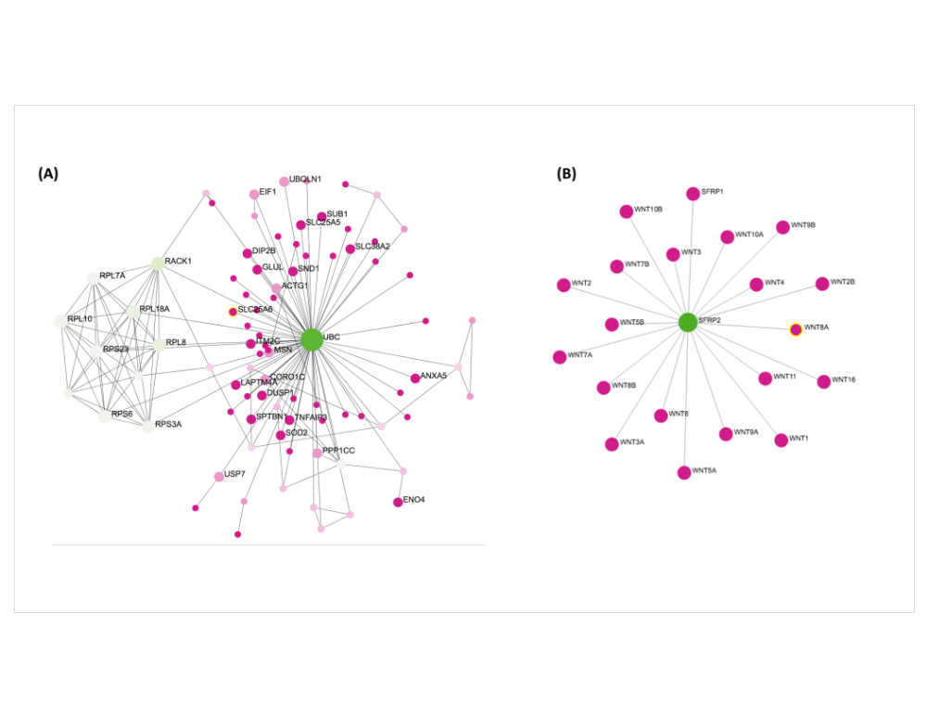
Figure 5

Figure 5. The human PPI network of DEGs was created via NetworkAnalyst. Hub genes are shown in the network displayed is (A) Subnetwork 1 and (B) Subnetwork 2 human PPI networks. The “green” colored nodes present up-regulated DEGs whereas the “purple” indicates the down-regulated DEGs. The gradual color alteration presents the gene expression levels. The number of the edges where the nodes linked each other presents the “node degree”. The node sizes show a hierarchy of the significant genes in-degree centrality, the greater quantity of neighbors a node has.

